* 1. **The World of the Microscope**

Measurement Units:

* 1 Km – 1000 m
* 1 m – 100 cm
* 1 cm – 10 mm
* 1 mm – 100 µm (Micrometres)
* 1µm – 1000 nm (Nanometres)

Calculating Magnification:

Magnification for a Light Microscope is calculated using Image Size ÷ Actual Size: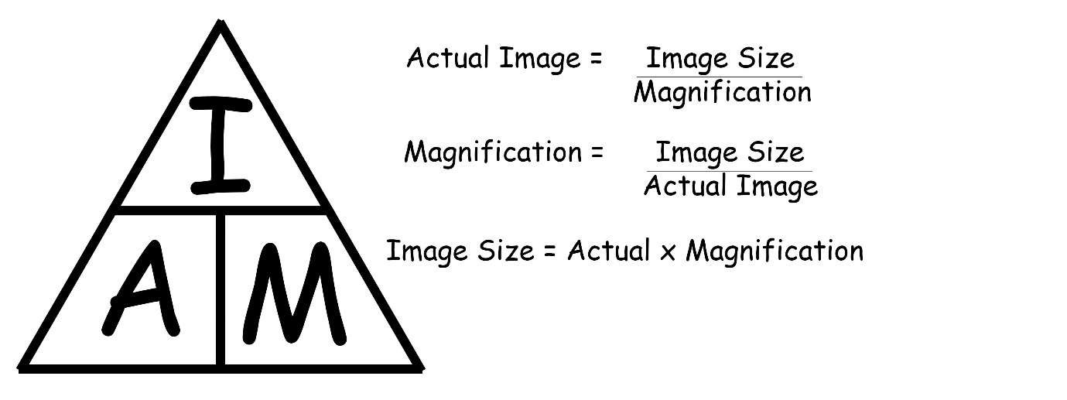

Resolving Power

There is a minimum distance where two objects close together can be distinguished from each other. If they are any closer, they will appear as one. Resolution is the ability to see two objects that are close together as separate, and it is measured in resolving power. A Light Microscope has a resolving power of 200 nm, whilst an electron microscope has the resolving power of 10 nm.

* 1. **Animal & Plant Cells**

Structure and Function of Animal Cells:

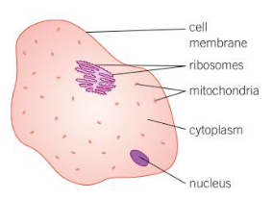

* Nucleus – Controls the activities of the cell and contains the genes, which are needed for the cell to duplicate. Average diameter of 10 µm.
* Cytoplasm – A liquid that holds all of the components of the cell. Where most of the chemical reactions in the cell occur.
* Cell Membrane – Controls what passes in, such as glucose, and out, such as urea, of the cell
* Mitochondria – Site of aerobic respiration, which releases energy for the cell. 1-2 µm in length and 0.2-0.7 µm in diameter.
* Ribosomes – Produces proteins that are required in the cell (protein synthesis)

Structure and Function of Plant Cells:

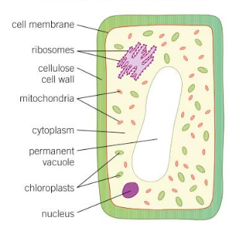

* Nucleus – Controls the activities of the cell and contains the genes, which are needed for the cell to duplicate. Average diameter of 10 µm.
* Cytoplasm – A liquid that holds all of the components of the cell. Where most of the chemical reactions in the cell occur.
* Cell Membrane – Controls what passes in, such as glucose, and out, such as urea, of the cell.
* Cell Wall – Made of cellulose, strengthens the cell and helps it to maintain shape.
* Mitochondria – Site of aerobic respiration, which releases energy for the cell. 1-2 µm in length and 0.2-0.7 µm in diameter.
* Chloroplasts – Site of photosynthesis, absorbing light so that the plant can produce food. Green colour due to the chlorophyll contained within.
* Permanent Vacuole – A space in the cytoplasm filled with cell sap. Keeps the cell rigid.
  1. **Eukaryotic and Prokaryotic Cells**

Eukaryotic Cells

Some examples of Eukaryotic Cells are Plant Cells and Animal Cells. All Eukaryotic Cells have:

* Cell Membrane
* Cytoplasm
* Nucleus containing Genetic Material

All Animals (including humans), Plants, Fungi and Protista are eukaryotes.

Prokaryotes

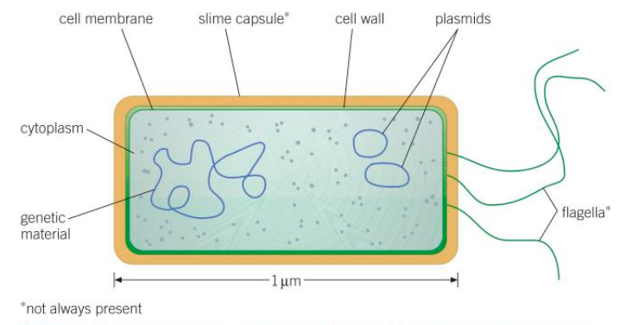

Bacteria are examples of Eukaryotes. They are 0.2-2 µm in size, which makes them 1-2 orders of magnitude smaller than eukaryotes. This means that you cannot see them without powerful microscopes. All Prokaryotes have:

* Cell Membrane
* Cytoplasm
* Cell Wall (without cellulose)
* Genetic Material (not contained in a nucleus)

The Genetic Material in Prokaryotes in not in a nucleus. Instead, the DNA is a single loop floating free in the cytoplasm. Some may contain extra, smaller rings of DNA. These are called Plasmids. They may contain code for things like antibiotic resistance.

Some bacteria also have a protective slime capsule around the cell wall. Other may have a flagellum (single) or flagella (plural). It is a long protein strand which lashes out, allowing them to move. Many bacteria have no effect on other organisms and some have a positive effect.

* 1. **Specialisation in Animal Cells**

Nerve Cells

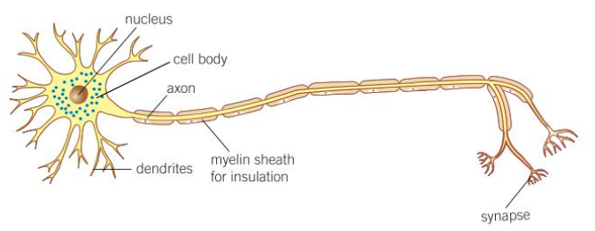

These cells are designed to carry electrical impulse around the body of an animal. They provide a rapid communication system between different parts of the body. They have many adaptations including:

* Lots of endings to make connections to other nerve cells,
* A long strand (axion) which carries the nerve impulse from one place to another.
* Synapses communicate to nerve cells or muscles using transmitter chemicals. They have lots on mitochondria to meet the energy demands required to make these chemicals.

Muscle Cells

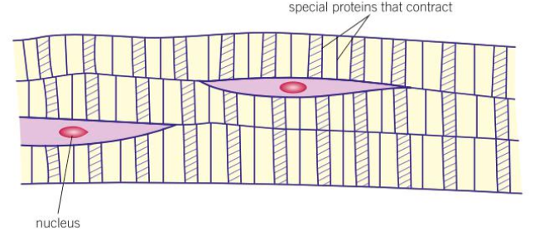

Muscle Cells are specialised cells which can contract and relax. Striated (striped) muscle cells work together in tissues called muscles. They contract and rela